PRESS RELEASE

0001 on 03.05.2021

“WHAT IS DEMOCRACY, ANYWAY?”

{See home page, (www.deborda.org).}

FROM NORTH BELFAST:

TEDx TALK NOW HAS OVER 50K DOWNLOADS

In Oct. 2017, in Vienna, Peter Emerson gave a TEDx talk on the theme, “What is democracy, anyway?” Since then, it has been shown in China, Iran, Russia, the USA, and all over the world: in all, it has been viewed over 50,000 times… and counting.

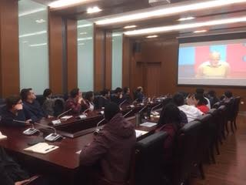

The TEDx Talk being viewed in Nankai University, Tianjin, April 2018 – (photo, the author) – prior to his power-point presentation on decision-making.

Peter Emerson
Director, the de Borda Institute
36 Ballysillan Road
Belfast BT14
07837717979

www.deborda.org

pemerson@deborda.org

